Year 10
OLNA class

Test 5 2018

Number- Integers and Measurement conversions


Name: ______________________ Class: ______ Time: 20 minutes (strict)
Total Marks:____/13

Resources: No calculator allowed

1. | In a kitchen, some food is stored at −18°C in a freezer and some at 4°C in the fridge. A roast is cooking in the oven at a temperature of 180°C.  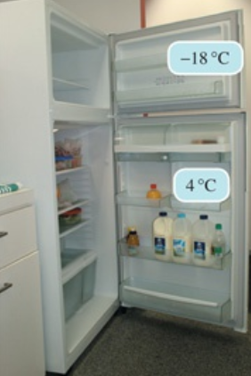  Before answering each of the following questions, draw a number line to show the positions of the temperatures.
a) | What is the difference in temperature between the food stored in the freezer and the food stored in the fridge?  (Hint: Difference = largest value − smallest value)
b) | What is the difference in temperature between the food stored in the fridge and the roast cooking in the oven?
c) | What is the difference in temperature between the food stored in the freezer and the roast cooking in the oven?
2. | The following is a homework sheet done by a student in Year 8. Correct her work for her and give her a mark out of six. Make sure you include the correct answer if her answer is wrong.  - −3 + −7 = −10  - −4 − −10 = −6  - −7 − 8 = 15  - 9 − −8 + −7 = 10  - 42 + 7 − −11 = 60  - − 17 + 4 − 8 = 23
3. | The standard marathon distance is 42.2 km. If a marathon race starts and finishes with one lap of Stadium Australia, seen at right, which is 400 m in length, what distance is run on the road outside the stadium?  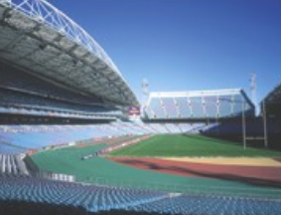
4. | Norbert is 1.53 m tall in bare feet. If he wears shoes with 6.3 cm thick soles, how high would he stand then? Give your answer in metres.
Choose the correct answer:
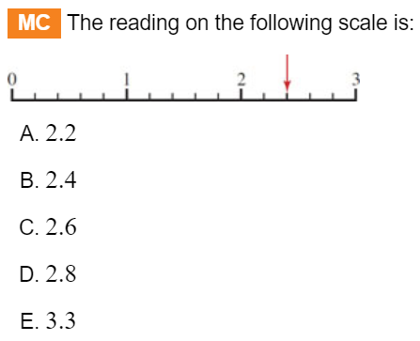

END OF TEST

